PHASE 2
Design Document

GeoInfo Access
§

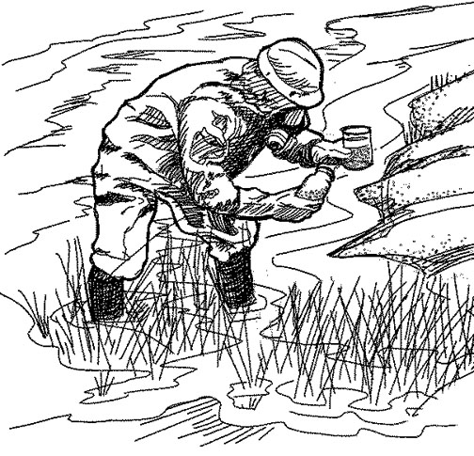

Developed by Jason Chalom 12S

Signoffs
Phase | Teacher | Date | Signature
2) Design Document | Mrs. de Wet

1. Summary
A software solution is needed which store raw data collected from can water, climatological and ecological tests done in a specific area and then process the data
The department of Environmental Affairs and Forestry, and the geography department at King David High School Linksfield require a computer solution to store ecological data and other geographical data collected in the field. Currently, The Department of Environmental Affairs uses an excel spreadsheet to store data collected from many different sources, and King David’s geography department stores their data on hardcopy. The Department of Environmental Affairs only stores raw data in the excel spreadsheet and does not process it since the people who claim the data from them are expected to process it themselves. The Department of Environmental Affairs also do not store ecological data but rather just water test sample data. Both parties require a software solution which is able to input water test data and other geological data as well as simple processing of the data such as measurement conversions. In this project I am going to make a Java program with an Access database and the ability to save to text files for storage.

The System requires a class which connects to the access database, a class which reads files, a class which writes files, a class which checks and then adds data to the database through the class which connects or bridges to the database and a main class which creates all the GUI Java Objects.

2. Presentation Layer ➔ GUI screens

GUI screen: GeoInfo Access (Main Screen)
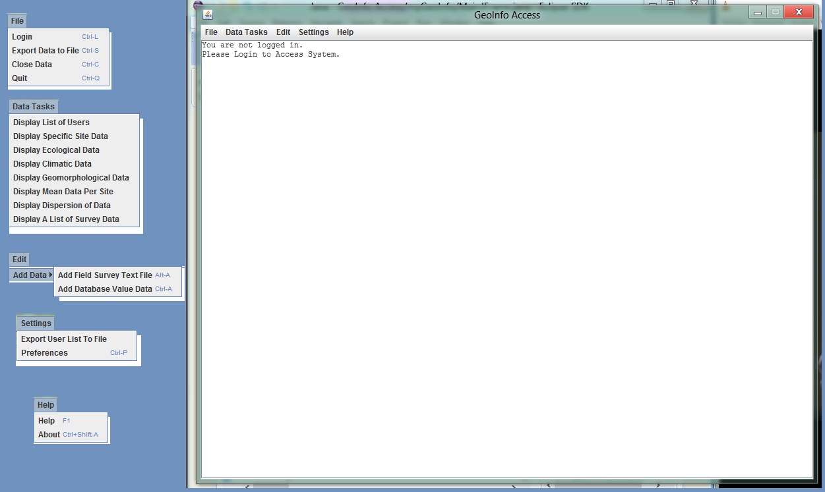

Description | This is the main window. This is where the data will be displayed, and also the menus located on this window help the user input data, select what data to display and also how to output the data.  The file menu enables the user to login, save the displayed data as a text file and also close the data and clear the main window and close the program.  The Database Tasks menu allows the user to select what data to display in the main window’s text area.  The edit menu enables the user to add data to the program either in the database or as a survey text file location stored in the database.  The Settings menu enables the user to define and create more users and also change the currently logged in user’s password.  The Help menu enables the user to open the about box to read the contact information of the designer of the program for further support. It also enables the user to open the help file (a pdf containing helpful information for the program).
Security Group | Any user which has been previously defined in the settings file or database.  It is a single user access ie only one user may access this window per instance of the program.  Anyone has access to the main window but if they are not logged in to the system they will only have access to the help, about box, login menu item and the quit menu item. An error message will be displayed if that ‘guest’ user tries to access any other functionality in the system.
Data | Main Text Area in the main window  - This Text area displays the output from the database  - The user selects specific data tasks which are then displayed in the text area.  - There are scroll bars which become visible when the text (output) goes beyond the boundaries of the text area.  - Other output, text comes from responses either errors or confirmations from other parts of the application.  - When a survey is added to the system, it is also displayed in the text area.  - The data is stored in the database or the text file which contains the survey.
Actions | Certain options have hot keys that when pressed on the main window will activate the same functions as pressing the menu items.  File Menu (click each menu option to perform their associated event)  - Login (Can Also be accessed with hot key CTRL-L)  - Will open the login window for the user to login.  - If the user is already logged in the option is disabled  - Export Data to File (Also Hot Key CTRL-S)  - Will open the save dialogue where the user is able to save the data displayed in the Text Area to file.  - Close Data (Also Hot Key CTRL-C)  - Will clear the data from the text area  - Quit (Also Hot Key CTRL-Q)  - Will close the application when activated.  Data Tasks Menu  - Display List of Users  - When clicked this will display the list of users of the system in the text area of the main window  - Display Specific Site Data  - When clicked this will display Specific site data from all the different tables of data in the database together in the text area of the main window.  - Display Ecological Data.  - When clicked this will display a list of the ecological data stored in the database in the text area of the main window.  - Display Climatic Data  - When clicked this will display a list of the climatic data stored in the database in the text area of the main window.  - Display Geomorphological Data  - When clicked this will display a list of the Geomorphological Data stored in the database in the text area of the main window.  - Display Mean Data per Site  - When clicked it will display the mean amount of the specific data grouped by each site in the database in the text area of the main window.  - Display Dispersion of Data  - When clicked it will display the Standard deviation of the specific data grouped by each site in the database in the text area of the main window.  - Display A List of Survey Data  - When clicked it will display a list of the surveys stored in the database in the text area of the main window, so that the user can find the survey on their computer.  Edit Menu  - Add Data  - Add Field Survey Text File (Hot Key ALT-A)  - When this is clicked an open dialogue appears where the user selects the survey to add the system.  - It will display the survey the user selected in the text area of the main window and also a list of sites in the database to use with the dialogue which also appears.  - When the user enters the site ID in the dialogue, the survey with the specified site id are added to the database tblSurvey.  - A confirmation Is then sent to the user if the survey is successfully added to the system.  - Add Database Value Data (Hot key Ctrl-A)  - When clicked this will open up the add data window so the user may enter data into the database.  Settings Menu  - Export User List To File  - When clicked this opens up a save dialogue, which the users selects the file to export the user list to.  - When this is done a confirmation dialogue will appear if everything functioned correctly.  - Preferences (Hot Key CTRL-P)  - When this is clicked it will open up the settings window.  Help Menu  - Help (Hot Key F1)  - When this is clicked the program will open the help pdf file with the associated program in the host computer. If the help file is missing this menu item will do nothing. If there is no associated program with the file there will be a error displayed to the user.  - About (Hot Key CTRL-SHIFT-A)  - When this is clicked the about box will open which gives the user general information about the program.

GUI screen: Enter your User Name and Password (Login Screen)

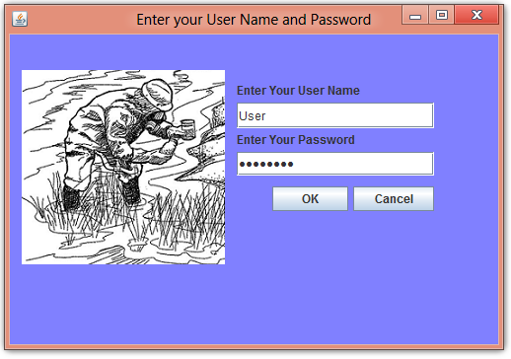
Description | This is the login window/dialogue.  This window enables the user to login to the system with their credentials which are stored in the database.  The main functionality to the application is not accessible to the user who is not currently logged into the system.  The login window also displays the logo of the software as to the clients specification.  It has two buttons, one which closes the window and cancels the operation and one which adds the inserted data to the database.  There are two text fields which the user will use to enter their login credentials.  There is an icon image which displays the logo of the software.  There are two labels which describe the function of the text fields.
Security Group | Anyone who accesses the program has access to this window. Only the people who have credentials stored in the database can successfully login to the system. Anyone who tries with faulty credentials will get an error message.
Data | UserName Textfield  - This is where the user inserts their username to be checked against the database. Their username is inserted into the system.  Password Textfield  - This is where the user inserts their password to be checked against the database. Their password is inserted into the system.
Actions | Click on cancel button  - This will cancel the login operation and close the login window  Click on OK button.  - This will send both the username and password into the database and check if firstly the username is valid and found in the database and secondly if the password matches exactly to the username (ie the same record) in the database entry.  - It will then either display an error dialogue to the user about an incorrect username and/or password, or it will login to the system using the users credentials.  - If the user does login to the system successfully than the login window will be closed and disabled. The login menu item will also be disabled and greyed out in the file menu.

GUI screen: GeoInfo Access (About Box)
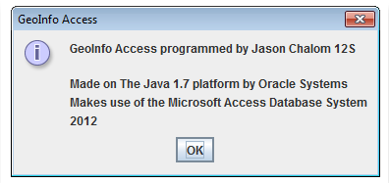

Description | - This is the about box which appears when the user clicks the about menu item in the help drop down menu.  - This is a logo used on a lot of Java applications to show that the dialog which the user is looking at is a message dialog. This is to show the user that the user must take notice of the information in the about box.  - This is the information which the user can view. It is there to tell the user who wrote the application, for what purpose and who the creator of the program in case there is a problem with the program.  - This is a closing cross on the border of the about menu. When the user clicks it the about box will close. It is there for the user to close the about box when they are done reading it.  - This is an “ok” button which the user can press when they are done to acknowledge that they have taken notice of the information displayed in the about box and to close the about box and go back to the main screen of the program to continue using it.
Security Group | Anyone can access this window. When the user who is operating the system opens the program they have access to the about dialogue whether they have logged in or not. One user can access the program at a time and so one user can access the about box at a time.
Data | The about box is a JOptionPane MessageDialogue which has its own textarea or label system. The data is stored in the code of the program.
Actions | - Click on the OK button to close the about box  - Click on the Red Cross in the right hand corner of the about box to close the about box.

GUI screen: Settings
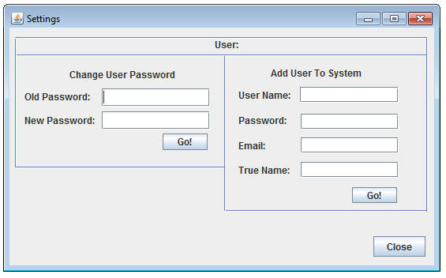

Description | This screen enables the user to either change the currently logged in user’s password or create a new user who is able to login to the system ie add a new user to the database.  There are two sections to this window.  The first section enables the current user to change his/her password within the database. There are two text fields where the user can enter their password data and two labels which help the user decide which text field is for which password (old or new). There is also a button labeled Go! Which will activate the process of changing the current user’s password.  The second section enables the user to create a new user who is able to login to the system. There are 4 text fields where the user can enter the new user’s credentials. There are also 4 labels which describe what each text field is for. There is a go! Button which will activate the process of adding a new user to the system once the data has been inputted.  There is a close button on the window which when clicked closes the window.  There are also JSeperators which are used to separate the different sections of the window.
Security Group | Only a single user at a time can access this system. That user has to be logged into the system also. If a user who is not logged in tries to access the window an error dialogue will be displayed, which tells the user that he/she is not logged in.
Data | Old Password Text field  - The user types in his/her current password  - It is then check with what is stored in the tblUser in the database  - If they do not match then an error will be displayed  New Password Text field  - The user types in the new password to replace the current one  - If the current password matches the old password, than the new password will replace the old password for the currently logged user in the database  - The replaced password if the old password matches the current password is stored in the database in the tblUser  User name text field  - The current user types in the user name of the new user.  - It is then stored in the database tblUser  Password text field  - The current user types in the password for the new user.  - It is then stored in the database tblUser  Email text field  - The current user types in the email for the new user.  - It is then stored in the database tblUser  True name text field  - The current user types in the true name for the new user  - It is then stored in the database tblUser
Actions | Change user password Go! Button  - When clicked the data which has been entered into the change password section of the window will be checked. Ie the old password which has been entered will be checked against the current password in the database.  - If the old password does not match the current one than an error message will be displayed.  - If the old password does match the current one than the new password replaces the current one in the database.  - If the password is successfully changes than a dialogue will appear telling the user this.  Add User To System Go! Button  - When clicked the data which has been entered in the add user section of the window is checked to make sure that it is not blank or just a whitespace.  - If the data is not valid than it will display a error message to the user  - If the data is valid than it will be added to the database, tblUser as a new record.  Close Button  - When this button is pressed by the user it closes the settings window.

GUI screen: Enter Your Data (Add Data Window)
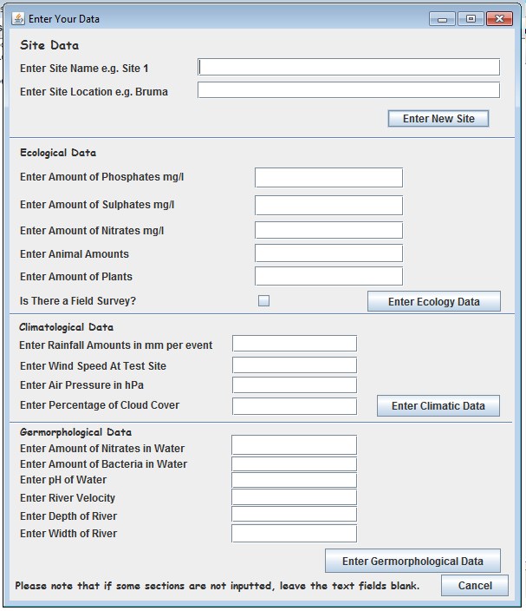

Description | This is the add data window. It enables the user to add data to the database.  It is divided into 4 sections, Site Data, Ecological Data, Climatological data and Geomorphological data.  The site window contains a cancel button which closes the window ie cancels the add data operation when clicked. It also contains a label which tells the user that the data can leave some sections blank. There are also separators which separate the different sections in the add data window.  The Site section contains two text fields which the user uses to enter site data into the system. There are also two labels which describe what data must be in the text fields. There is also a label which labels the site data field. There is also a Enter New Site data Button which is used by the user to enter the site data into tblSite in the database.  The ecological data section contains 5 text fields which the user uses to enter ecological data into the system. There is also a checkbox which the user uses to make the system know that there is a survey to connect to the ecological data table in the database. There are 6 labels in the section which tell the user what the check box and 5 text fields are for, and what data to enter in each one. There is also a Enter Ecology Data button which is used by the user to enter the data which they have inputted into the ecological data section into the database in the tblEcology.  The climatological data section contains 4 text fields which the user uses to enter climatological data into the system. There are also 4 labels in the section which tell the user what the text fields are for. There is also a label which describes Climatological Data section. There is also a enter climatic data button which allows the user the user to input the data into the tblClimate in the database.  The Geomorphological section contains 6 text fields where the user can use to enter geomorphological data into the database. There are also 6 labels which help the user identify which text field is used for what data. There is also a Enter Geomorphological Data which the user can use to input the data into the tblGermorph in the database.
Security Group | Only users who have credentials in the system ie in tblUSer in the database can access this window. Only one user can access the program at a time and so only one user can access the window at a time. . If a user who is not logged in tries to access the window an error dialogue will be displayed, which tells the user that he/she is not logged in.
Data | Site Section  Site Name text field  - The user types in the data in this field  - And the data is processed by the program and if everything functions correctly it is sent and stored in the database  - The label associated to this text field has text which is stored within the code of the program.  Site Location text field  - The label associated to this text field has text which is stored within the code of the program.  - The user types in the data in this field  - And the data is processed by the program and if everything functions correctly it is sent and stored in the database  Ecological Section  Ecological Amount of Phosphates text field  - The label associated to this text field has text which is stored within the code of the program.  - The user types in the data in this field  - And the data is processed by the program and if everything functions correctly it is sent and stored in the database  Ecological Amount of Sulphates text field  - The label associated to this text field has text which is stored within the code of the program.  - The user types in the data in this field  - And the data is processed by the program and if everything functions correctly it is sent and stored in the database  Ecological Amount of Nitrates text field  - The label associated to this text field has text which is stored within the code of the program.  - The user types in the data in this field  - And the data is processed by the program and if everything functions correctly it is sent and stored in the database  Ecological Animal Amounts  - The label associated to this text field has text which is stored within the code of the program.  - The user types in the data in this field  - And the data is processed by the program and if everything functions correctly it is sent and stored in the database  Field Survey Checkbox  - The user either check if there is a survey associated with the ecological data, if so it returns a true into the insert code which then does a whole lot of other processing and user input.  - The label associated to this text field has text which is stored within the code of the program.  Climatological Section  Rainfall Amounts text field  - The label associated to this text field has text which is stored within the code of the program.  - The user types in the data in this field  - And the data is processed by the program and if everything functions correctly it is sent and stored in the database  Wind Speed at Test Site text field  - The label associated to this text field has text which is stored within the code of the program.  - The user types in the data in this field  - And the data is processed by the program and if everything functions correctly it is sent and stored in the database  Air Pressure text field  - The label associated to this text field has text which is stored within the code of the program.  - The user types in the data in this field  - And the data is processed by the program and if everything functions correctly it is sent and stored in the database  Percentage of cloud cover text field  - The label associated to this text field has text which is stored within the code of the program.  - The user types in the data in this field  - And the data is processed by the program and if everything functions correctly it is sent and stored in the database  Geomorphological Section  Amount of nitrates in water text field  - The label associated to this text field has text which is stored within the code of the program.  - The user types in the data in this field  - And the data is processed by the program and if everything functions correctly it is sent and stored in the database  Amount of Bacteria in water text field  - The label associated to this text field has text which is stored within the code of the program.  - The user types in the data in this field  - And the data is processed by the program and if everything functions correctly it is sent and stored in the database  pH of Water text field  - The label associated to this text field has text which is stored within the code of the program.  - The user types in the data in this field  - And the data is processed by the program and if everything functions correctly it is sent and stored in the database  River Velocity text field  - The label associated to this text field has text which is stored within the code of the program.  - The user types in the data in this field  - And the data is processed by the program and if everything functions correctly it is sent and stored in the database  Depth of river text field  - The label associated to this text field has text which is stored within the code of the program.  - The user types in the data in this field  - And the data is processed by the program and if everything functions correctly it is sent and stored in the database  Width of river text field  - The label associated to this text field has text which is stored within the code of the program.  - The user types in the data in this field  - And the data is processed by the program and if everything functions correctly it is sent and stored in the database
Actions | ≪ Describe each action (e.g. click on button called btnOK will …..) that can be performed from this screen. This usually involves command buttons, menu items, etc.  Enter New Site Button Click  - When clicked the data in the text fields is sent to the program to be checked if it is valid.  - If it is valid than this site data is stored in the database in the tblSite.  Enter Ecology Data Button Click  - When clicked the data in the text fields is sent to the program to be checked if it is valid.  - If it is valid than the ecology data is stored in the database in the tblEcology  Enter Climatic Data Button Click  - When clicked the data in the text fields is sent to the program to be checked if it is valid.  - If it is valid than the Climatic data is stored in the database in the tblClimate  Enter Geomorphological Data Click  - When clicked the data in the text fields is sent to the program to be checked if it is valid.  - If it is valid than the Geomorphological data is stored in the database in the tblGermorph  Cancel Button Click  - When clicked the window will close.

3. Business Layer ➔ Sequencing
- Screen 1 GeoInfo Access (Main window)
  - User loads the program
    - When the application starts up
    - It creates an instance of the database connectivity class
    - This sets up the connection to the database and program
    - If an error occurs a error dialogue will be displayed instead of the main window and when it is closed by the user the application will close itself
      - The application runs a garbage collector to clear the heap
      - The Java system exits
    - If the connection to the database functions correctly a confirmation message is displayed in the text area of the main window
      - Also displayed is that the user is not logged in
The main window functions with user input. Basically no algorithms activate until user does something, once the initial loading of the program has happened of course.
  - User accesses any menu item without being logged in except the help menu items, the login menu item and quit menu item in the file menu.
    - A error dialogue is displayed to the user stating that the user is not logged in.
  - User clicks on the login menu item in the file menu or ctrl-l
    - The Login Window is called up using its accessor method
  - User clicks on the quit menu item in the file menu or ctrl - q
    - The application runs a garbage collector to clear the heap
    - The Java system exits
  - User clicks on the help menu item in the help menu Or F1
    - The program calls up the help pdf file and opens it with the associated application to open pdf files by the OS
  - User clicks on the about menu item in the help menu or Ctrl-Shift-A
    - The application will open a JOptionPane Dialog box with information about the creator of the application

ONCE THE USER IS LOGGED IN
  - User clicks on the export data to file menu item in the file menu or ctrl – s
    - The user first have to select a data task to display data on the main text area
    - Then the use clicks the export data to file menu item
    - This action opens a save jfilechooser dialogue
    - The user selects the directory and filename + extension to save the data to within the computer system
    - The savefile class is accessed and the data and filelocation/name are sent in and the file is written to the computer.
    - If it works successfully there will be a confirmation dialogue else an error dialogue will be displayed
  - User clicks on the close data menu item in the file menu or ctrl – c
    - It replaces the text in the text area of the main window with the text when the user logs in as well as a statement about clearing the data from the main window.
  - User clicks on the data tasks menu and selects one of the following menu items
    - The database reading class enables both display SQL codes and execute SQL Codes (see later)
    - The program will then use the according SQL code to the menu option that the user has selected
    - Click Display List of Users
      - When clicked this will display the list of users of the system in the text area of the main window
      - this SQL code will be sent into the Database reading class:
SELECT UserID, TrueName, Username FROM tblUser
    - Click Display Specific Site Data
      - When clicked this will display Specific site data from all the different tables of data in the database together in the text area of the main window.
      - this SQL code will be sent into the Database reading class:
SELECT tblSite.SiteID, tblSite.SiteName,
tblClimate.[RainfallAmnt(mm)],
tblClimate.[WindSpeed(kts)], tblClimate.[AirPressure(hPa)],
tblClimate.PercentageCloudCover,
tblGermorph.Bacteria
FROM ((tblSite INNER JOIN tblClimate ON
tblSite.SiteID = tblClimate.SiteID)
INNER JOIN tblEcology ON tblSite.SiteID =
tblEcology.SiteID) INNER JOIN tblGermorph ON
tblSite.SiteID = tblGermorph.SiteID
    - Click Display Ecological Data.
      - When clicked this will display a list of the ecological data stored in the database in the text area of the main window.
      - this SQL code will be sent into the Database reading class:
SELECT * FROM tblEcology
    - Click Display Climatic Data
      - When clicked this will display a list of the climatic data stored in the database in the text area of the main window.
      - this SQL code will be sent into the Database reading class:
SELECT * FROM tblClimate;
    - Click Display Geomorphological Data
      - When clicked this will display a list of the Geomorphological Data stored in the database in the text area of the main window.
      - this SQL code will be sent into the Database reading class:
SELECT *FROM tblGermorph;
    - Click Display Mean Data per Site
      - When clicked it will display the mean amount of the specific data grouped by each site in the database in the text area of the main window.
      - this SQL code will be sent into the Database reading class:
SELECT tblSite.SiteID, AVG(tblClimate.[RainfallAmnt(mm)])
AS [Mean RainfallAmnt], AVG(tblClimate.[WindSpeed(kts)]) AS
[Mean WindSpd(kts)], AVG(tblClimate.[AirPressure(hPa)]) AS [Mean AirPressure(hPa)], AVG(tblClimate.PercentageCloudCover)
AS [Mean PercentageCloudCover], AVG(tblGermorph.Bacteria)
AS [Mean Bacteria] FROM ((tblSite INNER JOIN tblGermorph ON tblSite.SiteID = tblGermorph.SiteID) INNER JOIN tblEcology ON
tblSite.SiteID = tblEcology.SiteID) INNER JOIN tblClimate ON
tblSite.SiteID = tblClimate.SiteID GROUP BY tblSite.SiteID
    - Click Display Dispersion of Data
      - When clicked it will display the Standard deviation of the specific data grouped by each site in the database in the text area of the main window.
      - this SQL code will be sent into the Database reading class:
SELECT tblSite.SiteID, StDev(tblClimate.[RainfallAmnt(mm)])
AS [Deviation RainfallAmnt], StDev(tblClimate.[WindSpeed(kts)])
AS [Deviation WindSpd(kts)], StDev(tblClimate.[AirPressure(hPa)])
AS [Deviation AirPressure(hPa)], StDev(tblClimate.PercentageCloudCover)
AS [Deviation PercentageCloudCover], StDev(tblGermorph.Bacteria)
AS [Deviation Bacteria] FROM ((tblSite INNER JOIN tblEcology
ON tblSite.SiteID = tblEcology.SiteID) INNER JOIN tblGermorph
ON tblSite.SiteID = tblGermorph.SiteID) INNER JOIN tblClimate
ON tblSite.SiteID = tblClimate.SiteID GROUP BY tblSite.SiteID;
    - Click Display A List of Survey Data
      - When clicked it will display a list of the surveys stored in the database in the text area of the main window, so that the user can find the survey on their computer.
      - this SQL code will be sent into the Database reading class:
SELECT *FROM tblSurvey;
  - User clicks on the edit menu and clicks the add data sub-menu
    - User clicks A field survey text file menu item or Alt-A
      - It will open up a open jfilchooser dialogue where the user must select the survey file to add to the system
      - Will use the openfile class to open the survey
      - If an incorrect survey file is selected than an error dialogue is displayed to the user.
      - Once the survey file is selected and opened by the user, it is displayed in the text area of the main window.
      - A list of the sites to use is also displayed in the main text area under the survey to add
      - A joptionpane input dialogue is also displayed asking for the site ID for the survey to add to the system
      - If the adding of the survey to the system ie database occurs correctly than a confirmation dialogue will appear to the user.

    - User clicks Add database value data menu item or ctrl-A
      - Will open the add data window using the accessor method for the window
  - User clicks on the Settings menu
    - User clicks on the export user list to file menu item
      - Will create a String variable which uses the database connectivity class to call up a list of user data from the database using this SQL code:
SELECT UserID, TrueName, Username FROM tblUser;
      - A save jfilechooser will open which will allow the user to select the location, filename and extension of the file to save the user list to.
      - The savefile class is accessed and the data and file location/name are sent in and the file is written to the computer
      - If everything goes correctly a confirmation dialogue is displayed else an error dialogue is displayed.
    - User clicks on the Preferences menu item or ctrl-P
      - Will open the settings window using its accessor method

- Screen 2 Login Screen <Enter your User Name and Password>
  - If the user clicks cancel button than it will close the login window without logging in to the system
  - The user enters his/her user name and password in the text fields
  - The user clicks OK
  - The program the determines if the user name exists in the database
    - If it is not than a error dialogue is displayed
    - If it does exists in the database than it check if the password typed in is in the same record as the username ie they correspond
      - If so than the isloggedin Boolean is made true so that all other methods are allowed to function and the user has access to the programs functions
        - The login file menu item is disabled and so is the login menu
        - A confirmation message is displayed in the text area of the main window
      - If not than a error dialogue will appear to the user

- Screen 3 Add Data Window <Enter Your Data>
Only one section of the window can be used at a time because when the add data sequence for each specific section is run, it closes the add data window
  - The user pressed the cancel button at the bottom of the add data frame
    - This will close the add data frame using the dispose method
  - Site Data Section
    - The user types in the amount of nitrates in water, amount of bacteria in water, pH of water, river velocity, depth of river and width of river text fields of the add data window under the geomorphological section
    - The user presses the enter geomorphological data button
    - The program sends the inputted information into the addData class
    - If so it will check if the inputted data is of the right data type
    - The program then checks if the inputted information is valid
    - If not it will return an error which is displayed in the text area of the main window
    - If the data is correct than it will send it to the database ie add it to the tblSite
      - Once that is done a confirmation message will be displayed in the text area of the main window
    - The Add data window will then be closed after any dialogues due to the add site data are closed
  - Ecological Data Section
    - The user types in the amount of phosphates, amount of Sulphates, amount of nitrates, amount of animals, amount of plants and check or not check if there is a field survey into the text fields and check box of the ecological data section of the add data window.
    - The user presses the Enter ecology data button
    - The program sends the inputted information into the addData class
    - If so it will check if the inputted data is of the right data type
    - The program then checks if the inputted information is valid
    - If not it will return an error which is displayed in the text area of the main window
    - If the data is correct than it will send it to the database ie add it to the tblEcology
      - Once that is done a confirmation message will be displayed in the text area of the main window
    - The Add data window will then be closed after any dialogues due to the add site data are closed
  - Climatological Data Section
    - The user types in the rainfall amount, wind speed, air pressure, and percentage of cloud cover into the text fields of the add data window under the climatological data.
    - The user presses the Enter Climatic Data button
    - The program sends the inputted information into the addData class
    - If so it will check if the inputted data is of the right data type
    - The program then checks if the inputted information is valid
    - If not it will return an error which is displayed in the text area of the main window
    - If the data is correct than it will send it to the database ie add it to the tblClimate
      - Once that is done a confirmation message will be displayed in the text area of the main window
    - The Add data window will then be closed after any dialogues due to the add site data are closed
  - Geomorphological Data Section
    - The user types in the amount of nitrates in water, amount of bacteria in water, pH of water, river velocity, depth of river, width of river into the text fields of the add data window under the geomorphology section of the add data window
    - The user presses the enter geomorphological Data button
    - The program sends the inputted information into the addData class
    - If so it will check if the inputted data is of the right data type
    - The program then checks if the inputted information is valid
    - If not it will return an error which is displayed in the text area of the main window
    - If the data is correct than it will send it to the database ie add it to the tblGermorph
      - Once that is done a confirmation message will be displayed in the text area of the main window
    - The Add data window will then be closed after any dialogues due to the add site data are closed
- Screen 4 Settings
  - Change user password section
    - The user inputs the user’s current password into old password and his/her new and desired password into new password.
    - User than presses the Go! Button within this specific section of the window
    - The program then checks that the old password matches the one currently stored in the database and linked to the currently logged in user
    - If the passwords do not match than an error dialogue is displayed to the user
    - If the passwords do match
      - It will then update the password connected to the currently logged in user in the database with the new and desired one.
  - Add user to system section
    - The user than inputs the user name, password, email and the true name of the new user into the text fields of this section to enter into the database.
    - The user than presses the Go! Button within this section
    - The program then sends this data into the AddData class.
    - The program then check to see if the data is valid
    - If the data is invalid then it will display a error dialogue to the user
    - If the data is valid the nit will add the new user to the tblUser in the database and display a message dialogue to the user.
  - Click the close button
    - Will close the settings window by using the dispose method associated with the window.
- Screen 5 <About Box>
  - The About Dialog Box will Contain the Following Information:
    - Who made the program
    - What year was it made
    - Who is it copyrighted to
  - If the user presses the OK button the About Dialog box will close
  - If the user presses the Cross in the right hand corner of the about box it will close.

4. Class design ➔ Objects / Classes to be developed

Class Name: MainJFrame
Purpose of class: To load and create a main method instance of the application while also providing the user with a graphical interface which is used to function the program. It also enables the user to input data into the database or access data in the database in a ordered manner.
Fields
Field Name | Data type | Description
isLoggedin | Boolean | This checks if the user has logged in. If false than the user is not logged in, it will change to true once the user has logged in.
SurveyPath | File | This will store the file path of the survey which the user has selected with the jfilechooser when that action event is called up by the user
SaveData | File | This will store the path of where to save the data and the filename and extension of the file to save the data as which the user has selected with the jfilechooser when that action event is called up by the user
SaveUsrList | File | This will store the path of where to save the user list and the filename and extension of the file to save the data as which the user has selected with the jfilechooser when that action event is called up by the user
QueryCode | String | This stores the SQL code which hwill be sent into the DBCode class via the DBLink object
SurveyID | String | This stores the surveyID which is used later
SurveyIsChecked | Boolean | This saves a true or false value depending if the user has checked is there a survey in the add Data window under the ecology section.
USerDBID | Int | This gets the userId of the currently logged in user from the database and then it is stored in this variable for future use.
DBLink | Object of DBCode | This is an object of the DBCode class which is used by the methods of this class to access the database and also change ie add values/data to the database
openfile | Object of OpenFile | This is an object of the OpenFile class which is used by the methods of this class to open the selected survey and return its data to be displayed to the user.
savefile | Object of SaveFile | This is an object of the SaveFile class which is used by the methods of this class to save the data or user list to the user’s desired file path, file name and file type
addData | Object of AddData | This is an object of the AddData class which is used by the methods of this class to add the data which the user has inputted into the add Data window into the corresponding table in the database.
Methods
Method name | Data type (if typed) / void | Description
MainJFrame | Default constructor | Calls the DBLink object and makes sure there are no errors with the connection to the database else it will close the application
passAcc actionPerformed | void | Will try to log the user into the system with give user credentials. If check fails will display error dialogue
LoginMnuItm actionPerformed | void | Will open the login window
QuitMnuItm actionPerformed | void | Will exit the application
CloseMnuItm actionPerformed | void | Will close the data in the text area of the main window
HelpSelectItm actionPerformed | void | Will open the help pdf with the OS associated program for pdf files
AboutMnuItm actionPerformed | void | Will call up a message dialogue with the about information
EnterDataButton actionPerformed | void | Will enter the geomorphology information into the addData class and display the returned message from the addData class.
ExportDataMnuItm actionPerformed | void | Will allow the user to export the text displayed in the text area of the main window.
CancelInputData actionPerformed | void | Will close the add data frame
PreferencesMnuItm actionPerformed | void | Will open the settings window
passCancel actionPerformed | void | Will close the login screen
AddTxtItm actionPerformed | void | Will allow user to input information to add a survey to the system. Ie stores its filename in the database.
AddDBaseDataItm actionPerformed | void | Will open the add Data window
DispSiteData actionPerformed | void | Will display the site data stored in the database on the text area of the main window
DispEcologyData actionPerformed | void | Will display the ecology data stored in the database on the text area of the main window
DispClimateData actionPerformed | void | Will display the climatic data stored in the database on the text area of the main window
DispListUsrs actionPerformed | void | Will display a list of users stored in the database on the text area of the main window
DispListSurveyMnuItm actionPerformed | void | Will display a list of surveys stored in the database on the text area of the main window
DispGermorphData actionPerformed | void | Will display the geomorphological data stored in the database on the text area of the main window
DispMeanData actionPerformed | void | Will display the mean data per site stored in the database on the text area of the main window
DispDispersionData actionPerformed | void | Will display the dispersion of the specific data per site stored in the database on the text area of the main window
ChangePassButton actionPerformed | void | Will change the current users password
AddUsrButton actionPerformed | void | Will add a new user to the system
CloseSettingsButton actionPerformed | void | Will close the settings window
ExportUsrsMnuItm actionPerformed | void | Will allow the user to export a list of users to file
EnterSiteDataButton actionPerformed | void | Will add the user entered site data to the database
EcologyDataButton actionPerformed | void | Will add the user entered ecology data to the database
ClimaticDataButton actionPerformed | void | Will add the user entered climatic data to the database

Class Name: DBCode
Purpose of class: Connection to database and execution of both accessor SQL and mutator SQL.
Fields
Field Name | Data type | Description
errorMessages | String | This field is used to store any errors which may occur in any methods of this class or its constructor
conn | Connection | This is the variable used to connect the database with the JDBC-ODBC bridge
Methods
Method name | Data type (if typed) / void | Description
spaces | String | spacing algorithm this method creates the spacing rather than doing it within the Display method it is a private method, it is not needed to be accessed externally inputted is the data to add spaces and the width ie the mount of spaces and outputted is the edited digest
line | String | Line spacing  line method  This method deals with the spacing of the underline part of the output from this class it is a private method, it is not needed to be accessed externally inputted is the data to add spaces and the width ie the amount of spaces outputted is the edited digest
Display | String | Display method  The method receives the inputted query from the main class  the method outputs the executed SQL from the database  This method aims to use the connection to the database to execute SQL code in order to get  information from the database and send it to the application for use
DisplaySurvey | String | DisplaySurvey method  The method recieves the inputed query from the main class  the method outputs the exectued SQL from the database  This method aims to use the connection to the database to execute SQL code in order to get  information from the database and send it to the application for use  it also has extra programming to ensure only the survey file name is displayed and not its whole path
DisplayWithoutHeadings | String | Display Method without headings  It is the same as the one above but without headings  The method recieves the inputed query from the main class  the method outputs the exectued SQL from the database  This method aims to use the connection to the database to execute SQL code in order to get  information from the database and send it to the application for us  THIS IS USED MAINLY FOR the login username and password
getErrorMessages | String | Return the ErrorMessages field
Execute | String | Code example found at:  http://www.exampledepot.com/egs/java.sql/UpdateData.html  http://www.daniweb.com/software-development/java/threads/196549/java-sql-update-syntax  Execute Method  The method receives the inputted query from the main class  the method will return if there is an error or if the query executed correctly  It will also return if the SQL code is executed  This method aims to use the connection to the database to execute SQL code in order to add information to the database

Class Name: AddData
Purpose of class: This class is used to determine the validity of the data which the user has entered into the program and if this data is valid it is inputted into the database.
Fields
Field Name | Data type | Description
QueryCode | String | This is the string which is used throughout the class to store the SQL codes which need to be executed into the database.
SiteID | int | This is the variable which stores the UserID of the current user who is logged into the program. It is used to when data is inserted into the database to identify the user.
SiteIsValid | boolean | This variable is used to determine if the site which the user enters for the data to be connected to is valid within the database.
openfile | Object of OpenFile class | This is a object of the OpenFile class so that if an incorrect survey Id is given by the user a proper survey is able to be entered into the database using the OpenFile to open the survey file.
DBLink | Object of DBCode Class | This is an object of the DBCode class which is used by the methods of this class to access the database and also change ie add values/data to the database.
Methods
Method name | Data type (if typed) / void | Description
AddUser | String | AddUser - method  inputed is the user name, password, and true name  also inputed is the email although this is not required to add a user to the system  outputed is either an error message or a confirmation message that  the user was entered into the system  the inputed email can be either a space or null
AddSite | String | AddSite - Method  inputed is the sitename, sitelocation and surveydate and also UserID  the same site can be done on different days ie different siteID  outputed is an error message or confirmation of adding to the db.  It checks if the data is empty or not and then adds it to the database if the data is valid it also updates the siteID Field
AddEcology | String | AddEcology - Method  Inputed is the amount of phosphates, sulphates, nitrates, plant amounts, animal amounts  It is all Strings because the type is checked within the method  Also inputted is the SurveyId and USerID which are found/given from the main class and also the boolean for the checkbox  outputed is either an error message or a confirmation message that the data was added to the db  the method check firstly if the data inserted is null or contains whitespaces  the method checks if the inserted variables are valid types to that of the data base
AddClimate | String | AddClimate - Method  Inputed is the amount of rainfall, wind speed, air pressure and the percentage of cloud cover of an area.  It is all Strings because the type is checked within the method  Also inputted is the SiteID it must be found in the main method  outputed is either an error message or a confirmation message that the data was added to the db  the method check firstly if the data inserted is null or contains whitespaces  the method checks if the inserted variables are valid types to that of the data base
AddGermorph | String | AddGermorph - Method  Inputed is the amount of Nitrates in the soil, Bacteria, pH, River Velocity, The River depth and the river width.  It is all Strings because the type is checked within the method  Also inputted is the SiteID it must be found in the main method  outputed is either an error message or a confirmation message that the data was added to the db  the method check firstly if the data inserted is null or contains whitespaces  the method checks if the inserted variables are valid types to that of the database
isInteger | boolean | These methods determine the type of variable of a given string ie a Integer  inputed into every method of this purpose is the input string  outputted is the boolean if the variable is that type ie true or otherwise false  each of these methods are private since they will only be accessed from within the class  the name of each class is self-explanatory so this is the summary for the following methods ie this specific class checks if the inputted String is an integer and returns a true or false.
isDouble | boolean | These methods determine the type of variable of a given string ie a Double.  inputed into every method of this purpose is the input string  outputted is the boolean if the variable is that type ie true or otherwise false  each of these methods are private since they will only be accessed from within the class  the name of each class is self-explanatory so this is the summary for the following methods ie this specific class checks if the inputted String is a double and returns a true or false

Class Name: OpenFile
Purpose of class: This class is used to open files which contain data in order for that data to be used by the program. Ie it reads text from text files and returns the text.
Fields
Field Name | Data type | Description
none
Methods
Method name | Data type (if typed) / void | Description
OpenSurvey | String | This method opens survey data  There is no need for arrays since the data may not have any logical and uniform structure so it must just check if the survey file is correct, e.g. data validation  It must then make the survey file if it is valid into a String variable  OpenSurvey method  input the file path from the importjfilechooser in the gui main method  determine if the file is valid  return the file data as a String

Class Name: SaveFile
Purpose of class: This class is used to write data which is inputted from the main class to a file on the computer.
Fields
Field Name | Data type | Description
ErrorMessages | String | This field is used to store any errors which may occur in any methods of this class or its constructor
Methods
Method name | Data type (if typed) / void | Description
ExportData | String | method -ExportData This method is able to save the text file  Inputted is the file to write to and its path (one variable)  Also inputted is the data to write to the file  outputted is a message which either return a job completed or an error message
getErrorMessages | String | Return the ErrorMessages field

5. Persistent Storage Design ➔ Database Layer
.≪Must make use of persistent storage design! Explain what your data structures are – if reading from text files / typed files, specify their format. Databases need to be described in detail. Correct data types must be used! If you use text fields, you must indicate more detail, e.g. number of characters. Data types used must be appropriate to the purpose and match the specification document requirements.≫

≪Do the following for each table in a database:≫

Table name: | tblClimate
Links / Relationships: | {SiteID} – tblSite
Fields: | Field name | Data type | Description
Fields: | ClimateID | AutoNumber | Primary Key; Number of climate data record.
Fields: | SiteID | Number (Long integer) | Number of site data record.
Fields: | RainfallAmnt(mm) | Number (double) | The amount of rainfall recorded at that particular site
Fields: | WindSpeed(kts) | Number (double) | The wind speed recorded at that particular site
Fields: | AirPressure(hPa) | Number (double) | The Air pressure recorded at that particular site
Fields: | PercentageCloudCover | Number (double) | The percentage of cloud cover in quarters recorded at that particular site

Table name: | tblEcology
Links / Relationships: | {SiteID} → tblSite and {SurveyID} → tblSurvey
Fields: | Field name | Data type | Description
Fields: | EcologyID | AutoNumber | Primary Key; Number of Ecology data record.
Fields: | SiteID | Number (Long integer) | Number of site data record.
Fields: | SurveyID | Number (Long integer) | Number of survey data file information record.
Fields: | Phosphates | Number (Double) | The amount of phosphates in the soil recorded at that particular site
Fields: | Sulphates | Number (Double) | The amount of Sulphates in the soil recorded at that particular site
Fields: | Nitrates | Number (Double) | The amount of Nitrates in the soil recorded at that particular site
Fields: | PlantAmnt | Number (Integer) | Amount of plants at test site.
Fields: | AnimalAmnt | Number (Integer) | Amount of animals at test site.

Table name: | tblGermorph
Links / Relationships: | {SiteID} → tblSite
Fields: | Field name | Data type | Description
Fields: | GermorphID | AutoNumber | Primary Key; Number of geomorphology data record.
Fields: | SiteID | Number (Long integer) | Number of site data record.
Fields: | Nitrates | Number (Double) | The Amount of Nitrates in the water recorded at that particular site
Fields: | Bacteria | Number (Double) | The Amount of bacteria in the water recorded at that particular site
Fields: | pH | Number (Double) | The pH of the water recorded at that particular site
Fields: | RiverVelocity(M/S) | Number (Double) | The river velocity at that particular site
Fields: | RiverDepth(M) | Number (Double) | The river depth at that particular site
Fields: | RiverWidth(M) | Number (Double) | The river width at that particular site

Table name: | tblSite
Links / Relationships: | {UserID} → tblUser AND {SiteID} → tblClimate, tblEcology, tblGermorph, and tblSurvey
Fields: | Field name | Data type | Description
Fields: | SiteID | AutoNumber | Primary Key; Number of site data record.
Fields: | SiteName | Text (255) | The name of the test site (ie site1)
Fields: | SiteLocation | Text (255) | The location of the test site (ie Bruma)
Fields: | UserID | Number (Long integer) | Number of User data record.

Table name: | tblSurvey
Links / Relationships: | {SurveyID} → tblEcology, {UserID} → tblUser and {SiteID} → tblSite
Fields: | Field name | Data type | Description
Fields: | SurveyID | AutoNumber | Primary Key; Number of survey data file information record.
Fields: | TextFileName | Text (255) | The name of the text file which is storing the survey data.
Fields: | UserID | Number (Long integer) | Number of User data record.
Fields: | SiteID | Number (Long integer) | Number of site data record.

Table name: | tblUser
Links / Relationships: | {UserID} →tblSite, and tblSurvey
Fields: | Field name | Data type | Description
Fields: | UserID | AutoNumber | Primary Key; Number of User data record.
Fields: | Username | Text (255) | The username of the particular user, used to login
Fields: | Password | Text (255) | The password of the particular user, used to login
Fields: | email | Text (255) | The email of the particular user
Fields: | TrueName | Text (255) | The true name of the particular user

The text files which contain the survey data do not have any logical layout. It is up to the user to determine how to layout the data in the file. The system just displays it as is and also records its filename in the database. The survey files have to be *.txt to function else the program will return an error.

Explanation of data storage
Database – it is an easy way to store, access and collate + connect different data through Java based code
- tblClimate – stores the climatic data
  - ClimateID
    - Is used internally to number each of the climate records so that they can be identified.
  - SiteID
    - Is used to identify the site at which this data was collected
    - It has to be checked with the list of sites in tblSite to make sure that this SiteID exists.
  - RainfallAmnt(mm)
    - This data must be checked that it is not empty
    - It must be a double type variable
    - It cannot be a negative
  - WindSpeed(kts)
    - This data must be checked that it is not empty
    - It must be a double type variable
    - It cannot be a negative
    - It must be between 0 and 50 kts
  - AirPressure(hPa)
    - This data must be checked that it is not empty
    - It must be a double type variable
    - It cannot be a negative
  - PercentageCloudCover
    - This data must be checked that it is not empty
    - It must be a double type variable
    - It cannot be a negative
- tblEcology – stores the ecological data
  - EcologyID
    - Is used internally to number each of the ecology records so that they can be identified
  - SiteID
    - Is used to identify the site at which this data was collected
    - It has to be checked with the list of sites in tblSite to make sure that this SiteID exists.
  - SurveyID
    - Is used to identify which survey is linked to this ecology data
  - Phosphates
    - This data must be checked that it is not empty
    - It must be a double type variable
    - It cannot be a negative
  - Sulphates
    - This data must be checked that it is not empty
    - It must be a double type variable
    - It cannot be a negative
  - Nitrates
    - This data must be checked that it is not empty
    - It must be a double type variable
    - It cannot be a negative
  - PlantAmnt
    - This data must be checked that it is not empty
    - It must be a integer type variable
    - It cannot be a negative
  - AnimalAmnt
    - This data must be checked that it is not empty
    - It must be a integer type variable
    - It cannot be a negative
- tblGermorph – stores the geomorphological data
  - GermorphID
    - Is used internally to number each of the geomorphology records so that they can be identified
  - SiteID
    - Is used to identify the site at which this data was collected
    - It has to be checked with the list of sites in tblSite to make sure that this SiteID exists.
  - Nitrates
    - This data must be checked that it is not empty
    - It must be a double type variable
    - It cannot be a negative
  - Bacteria
    - This data must be checked that it is not empty
    - It must be a double type variable
    - It cannot be a negative
  - pH
    - This data must be checked that it is not empty
    - It must be a double type variable
    - It cannot be a negative
  - RiverVelocity(M/S)
    - This data must be checked that it is not empty
    - It must be a double type variable
    - It cannot be a negative
  - RiverDepth(M)
    - This data must be checked that it is not empty
    - It must be a double type variable
    - It cannot be a negative
  - RiverWidth(M)
    - This data must be checked that it is not empty
    - It must be a double type variable
    - It cannot be a negative
- tblSite – stores the site data
  - SiteID
    - Is used to number each site record so that each one can be identified.
  - SiteName
    - Must be a string
  - SiteLocation
    - Must be a string
  - UserID
    - It is used to identify which user created the site data.
- tblSurvey – stores the survey data ie the name of the survey text file
  - SurveyID
    - Is used to number each survey record so that each one can be identified.
  - TextFileName
    - Must be a string
    - The filename must be a *.txt extension
    - The file location must be removed before it is inputted into the database
  - UserID
    - It is used to identify which user created the survey.
  - SiteID
    - Is used to identify the site at which this data was collected
    - It has to be checked with the list of sites in tblSite to make sure that this SiteID exists.
- tblUser – stores the user credentials so that those user can have access to the system while no one else does.
  - UserID
    - Is used to number each user record so that each one can be identified.
  - Username
    - Must be a string
    - When the user is trying to login the username which is entered is checked to see if it exists in the database
  - Password
    - Must be a string
    - When the user tries to login the password which is entered is checked against the username entered(if it is in the database) to see if they are connected ie in the same record
  - Email
    - Must be a string
  - TrueName
    - Must be a string

Text file – is an easy way to store survey data which the user can then open. There are many different programs in almost every operating system which can open text files.
- The data is not changed but the name of the text file is saved in the database so that when the user gets a list of the surveys stored in the database they can easily find the survey file on their computer and open it.

